

**Score**

**CSP20443P : Structures of Programming Languages 100**

**COLLEGE OF BUSINESS AND ACCOUNTANCY**

University of Negros Occidental-Recoletos

Midterm Examination – October 24, 2022

**C87**

**Besa Cabalan**

**Section Remarks**

**Last Name 1 Last Name 2**

**Lending System**

1. Construct a folder Lastname1Lastname2Midterm in Drive D or E
2. Create a project lendingproject inside the newly made folder
3. Follow the SETTINGS and CONTENT from our previous sample project

* Database name : lendingdb
* Menu name : lendingmenu
* Form name : lendingapp (interface of loan application)
* Table name : lending

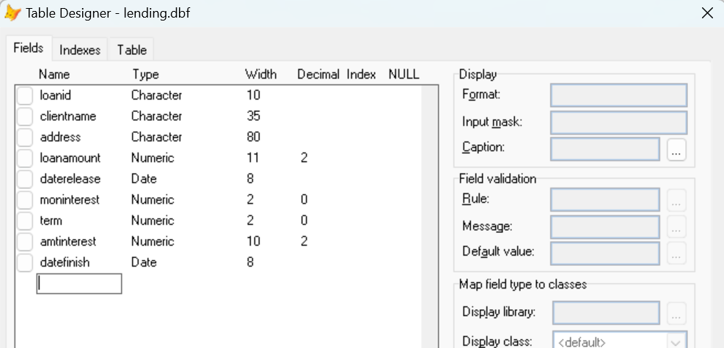

1. Table of Interpretation and Setup

Standard Number of Days per Month = 30 days

Loan Transaction ID – LN22001, LN22002 (LN + 2 digit year + 3 digit sequence #)

|  |  |  |  |
| --- | --- | --- | --- |
| Field Name | Description | Control | Formula |
| loanid | Loan Transaction ID | Disabled |  |
| clientname | Customer Full Name | Enabled |  |
| address | Customer Address | Enabled |  |
| loanamount | Amount of Applied Loan | Enabled |  |
| daterelease | Date Release of Loan Amount | Enabled |  |
| moninterest | Monthly Interest % | Enabled |  |
| term | Number of Months of Loan Payment | Enabled |  |
| amtinterest | Total Interest Amount | Disabled |  |
| datefinish | Date Payment Completed | Disabled |  |

1. Sample Entry:

Loan Amount = 10,000

Date Release = 09/01/2022

Monthly Int % = 5% (diminishing)

Term = 4

Total Interest Amount = 1,250

Date Finish = 01/01/2023

Generated Amortization (Printable)

10/01/2022 2,500 + 500 3,000 (10,000 x 5%)

11/01/2022 2,500 + 375 2,875 (7,500 x 5%)

12/01/2022 2,500 + 250 2,750 (5,000 x 5%)

01/01/2022 2,500 + 125 2,625 (2,500 x 5%)